
NEXAMART
E-Commerce Sales & Customer Analytics

24 July 2026
manjeti bobby
HYDERABAD

1. Data Cleaning Summary
The raw export (nexamart_raw.csv) contained 12,180 transaction rows. After cleaning, the working dataset has 12,065 rows. Key corrections made before analysis:
- 115 duplicate rows removed (a known logging glitch).
- Missing values imputed: discount_pct (181 rows), payment_method (121), customer_age (361), delivery_days (240), rating (966).
- 12 impossible customer ages (recorded above 100) corrected using known values or capped to the mean; negative ages and delivery_days corrected.
- Text fields standardized (casing, whitespace) and date formats unified across the two source systems.
- Two very high unit_price rows (a Rs 76,650 smart watch and a Rs 59,866 mixer grinder) were kept as plausible premium items, not treated as errors.
- Two very high quantity rows (152 and 114 units in a single order) were kept, as there was no basis to confirm they were data-entry errors.
All downstream figures below are based on this cleaned dataset (12,065 rows, Jan 2024 - Dec 2025).

2. Overall Sales Performance (Q1)
Total revenue across the two-year window is approximately Rs 2.06 crore (Rs 20,642,739), from about 12,013 orders, at an overall average order value (AOV) of roughly Rs 1,718.
The month-over-month trend is not flat - it is sharply seasonal. October, November and December generate close to half of all revenue (about 50%) and half of all orders, despite being only 6 of the 24 months in the dataset. This pattern repeats in both 2024 and 2025: order counts roughly triple in these three months (from ~300-350/month to ~1,000/month) while AOV stays broadly similar. This points to a genuine, recurring festive-season demand surge (consistent with India's Oct-Dec shopping season) driven by order volume rather than higher spend per order - not a one-off data artifact, since it recurs in both years.
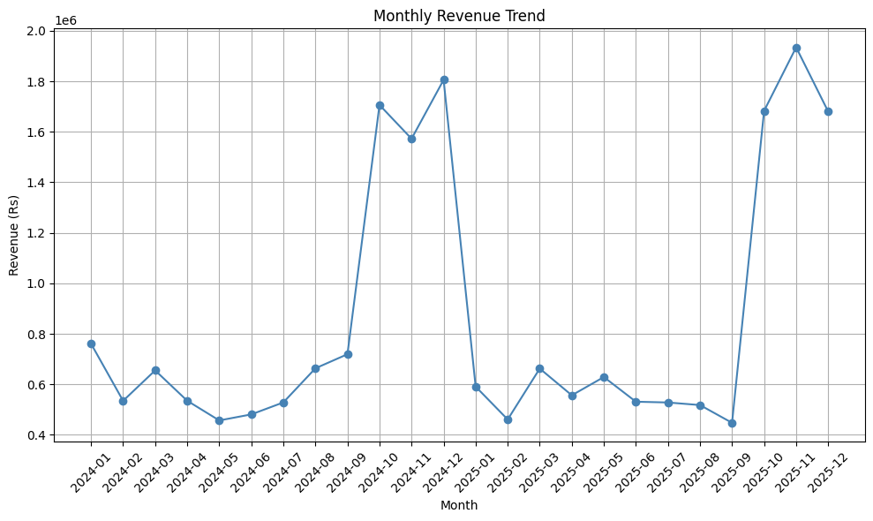
Monthly revenue trend, Jan 2024 - Dec 2025

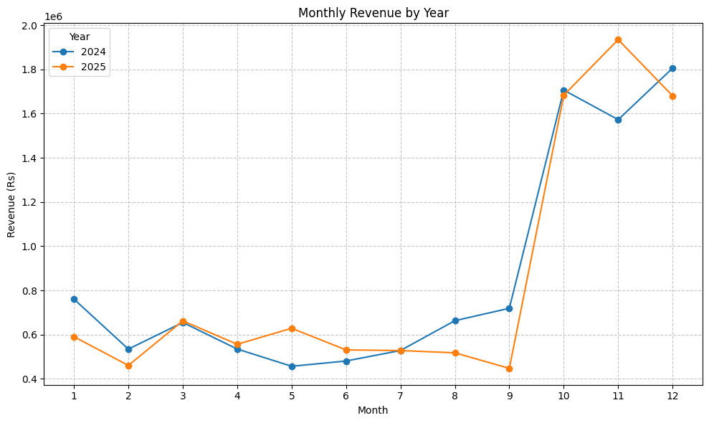

Monthly revenue overlaid by year, confirming the Oct-Dec surge repeats annually

Ruling Out Outliers as the Cause of the Oct-Dec Surge
Because the Oct-Dec charts show a visible jump, it is a fair question whether this is being driven by a handful of extreme (outlier) transactions rather than a genuine trend. This was checked directly on the cleaned data using the IQR method (flagging any order with revenue beyond Q3 + 1.5 x IQR) and comparing Oct-Dec against the rest of the year:
- Outlier rate is almost identical in both periods: 6.26% of Oct-Dec orders are outliers vs 6.24% for the rest of the year. If a few freak transactions were driving the spike, Oct-Dec would show a much higher outlier concentration - it does not.
- Order count nearly triples (about 2,024 orders/month in Oct-Dec vs about 671/month the rest of the year). Individual outlier rows cannot triple a row count - this only happens when genuinely more transactions occur.
- The surge survives outlier removal. Even after stripping every flagged outlier row out entirely, Oct-Dec revenue (about Rs 11.3L/month) is still roughly 3x a typical non-festive month (about Rs 3.3-3.5L/month).
- Average order value is nearly identical in both periods (Rs 1,710 in Oct-Dec vs Rs 1,712 the rest of the year) - people are not spending more per order, there are simply far more orders.
Conclusion: the Oct-Dec surge is genuine, volume-driven seasonality (consistent with India's festive shopping season), not an artifact of a small number of extreme transactions.
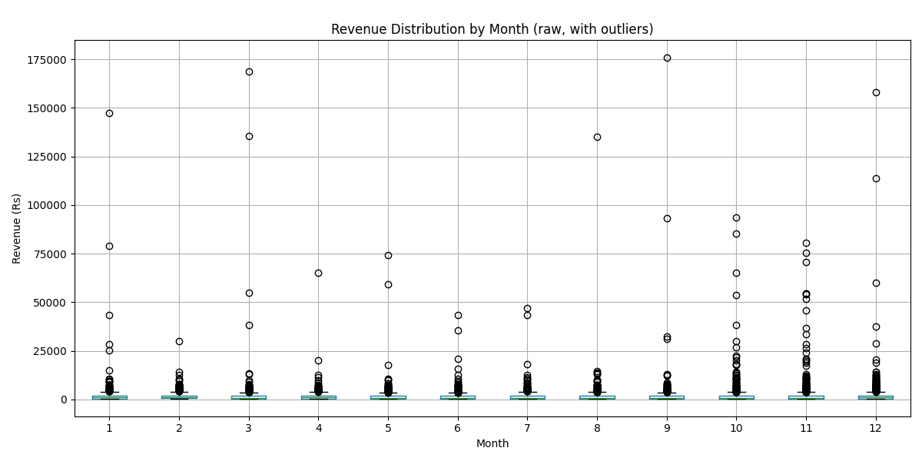
Revenue distribution by month - outlier points (circles) are present in every month at a similar rate, not concentrated in Oct-Dec

3. Category and Region Performance
Electronics (Rs 79.1L) and Fashion (Rs 52.1L) are the two leading revenue categories, together contributing well over half of total revenue. Home & Kitchen (Rs 29.6L), Sports (Rs 21.5L) and Beauty (Rs 18.5L) follow, with Books lowest (Rs 5.5L).
By region, East is the one region generating revenue below the four-region average (Rs 49.26L), while North, South and West are at or above it. This is a volume/mix effect rather than a pricing one - see Q3-Q4 below, where per-order value does not differ significantly by channel or region.
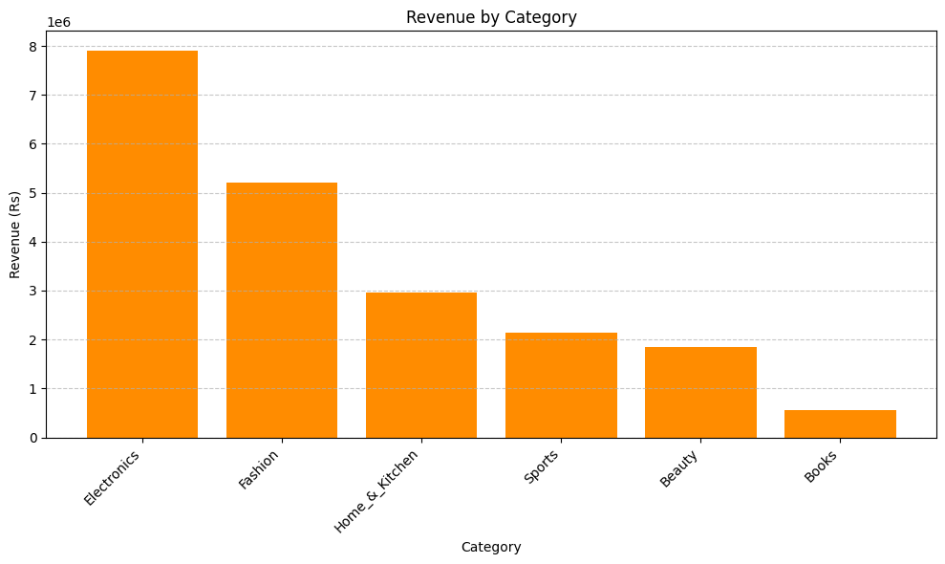
Revenue by product category
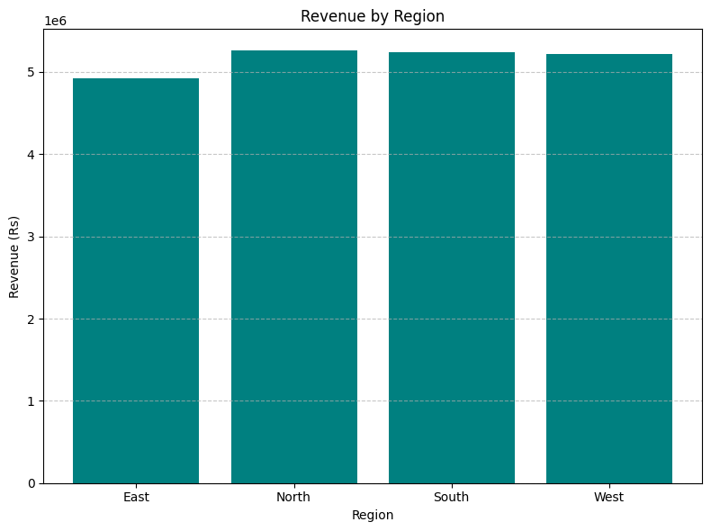
Revenue by region

4. Channel vs Order Value
An independent-samples t-test comparing order value on Mobile App (AOV Rs 1,713) vs Website (AOV Rs 1,677) found no statistically significant difference (Levene's p = 0.88, t-test p = 0.72). Customers spend about the same per order regardless of which of these two channels they use.

5. Region vs Order Revenue
A one-way ANOVA across North, South, East and West found no statistically significant difference in per-order revenue by region (p = 0.69). East's lower total revenue (Section 3) is therefore best explained by fewer orders or a different product mix in that region, not by customers there spending less per order.

6. Category vs Return Likelihood
A chi-square test of independence found a highly significant association between product category and return likelihood (p < 0.001). Return rates by category:
- Fashion: 14.2% (379 of 2,670 orders)
- Electronics: 13.4% (401 of 2,995 orders)
- Books: 5.8%
- Sports: 5.2%
- Beauty: 5.2%
- Home & Kitchen: 5.0%
Fashion and Electronics are simultaneously the top two revenue categories and the two categories with the highest return rates (roughly 3x the other categories) - this is the clearest quality-control priority in the dataset.

7. Discount Percentage vs Rating
Pearson correlation between discount percentage and customer rating is effectively zero (r = -0.009, p = 0.32). Discounting is not moving customer satisfaction scores in either direction - it should be evaluated purely on its effect on volume and margin, not as a satisfaction lever.

8. Customer Segments and Revenue
Middle-Aged customers (36-64) generate the most revenue (Rs 1.17 crore), well ahead of Young Adults 18-35 (Rs 72.2L) and Seniors 65+ (Rs 16.9L); customers under 18 contribute negligibly (Rs 2.6L). By gender, Female customers generate the most revenue (Rs 74.8L), though Male and Other are relatively close behind (Rs 64.7L and Rs 67.0L respectively) - the gap is not as pronounced as the age-group gap.
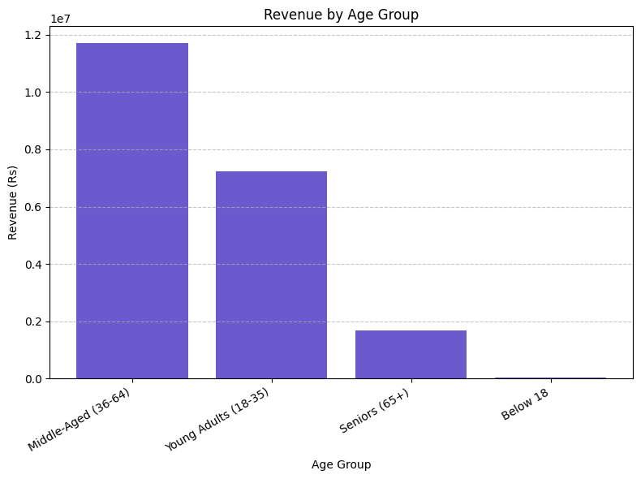
Revenue by customer age group

9. Return Rate by Revenue-Weighted Category
Combining Sections 3 and 6: Electronics and Fashion together account for the majority of revenue and also carry the highest return rates. Reducing returns in these two categories specifically would have a disproportionately larger impact on net revenue than an equivalent improvement anywhere else.

10. Delivery Time vs Rating and Region
Delivery time shows no significant correlation with customer rating (Pearson r = 0.0016, p = 0.86) - customers are not rating orders lower simply because delivery took longer. However, a regional ANOVA shows delivery time differs very significantly by region (p < 0.001), meaning some regions are consistently slower than others, independent of how customers rate the experience.

11. Role-Specific Recommendations

Marketing Managers
- Launch targeted festive campaigns from September to maximize October-December sales - revenue consistently peaks in Q4 (Section 2).
- Focus digital advertising on customers aged 18-64, especially the 36-64 segment, since this group generates the highest revenue (Section 8).
- Run personalized email/SMS promotions for repeat customers ahead of the festive season to encourage repeat purchases and lift conversions.
- Offer discounts or bundle deals for the lowest-performing category, Books, to help improve its sales - note that discounting has no measurable effect on ratings either way (Section 7), so it can be used freely as a volume lever here.
- Create region-specific campaigns for the East region, since it generates lower total revenue than other regions (Section 3).

Operations Managers
- Increase inventory levels before October to avoid stock shortages, since demand increases sharply in Q4 in both years on record.
- Schedule additional warehouse and delivery staff during peak months to support the higher order volumes seen in Oct-Dec.
- Improve demand forecasting using the historical monthly sales trend, which shows a consistent, repeatable seasonal pattern rather than random spikes.
- Monitor supply chain and fulfillment performance for Electronics and Fashion specifically - these are both the highest revenue-generating categories and the categories with the highest return rates (Sections 6 and 9).
- Investigate and optimize logistics in the regions with slower delivery times, since delivery time differs significantly by region (Section 10) even though it does not currently affect ratings.

Category Managers
- Prioritize Electronics and Fashion with premium placement and higher inventory allocation, as these categories contribute the highest revenue.
- Review the performance of Books and Sports categories, which generate the lowest revenue, to identify whether the issue is assortment, pricing, or demand.
- Introduce product bundles and cross-selling within and across categories (e.g., Electronics plus accessories) to increase average order value.
- Pair the return-rate data (Section 6) with product-level review, since Fashion and Electronics returns are disproportionately high relative to their share of orders - likely candidates are fit/sizing issues for Fashion and DOA/mismatch issues for Electronics.
- Analyze customer preferences by age group and adjust the product mix accordingly, since middle-aged customers (36-64) contribute the most revenue by a wide margin (Section 8).

Summary
Marketing: focus festive-season campaigns, target the 18-64 (especially 36-64) age group, and run region- and category-specific promotions for East and Books.
Operations: build inventory and staffing plans around the confirmed, repeatable Q4 surge, and prioritize supply-chain and delivery-time fixes for the highest-revenue, highest-return categories and slower regions.
Category Managers: protect and grow Electronics and Fashion while investigating why Books and Sports underperform and use the age-group data to guide product mix.

